The two programs were written to solve Initial Value Problems;

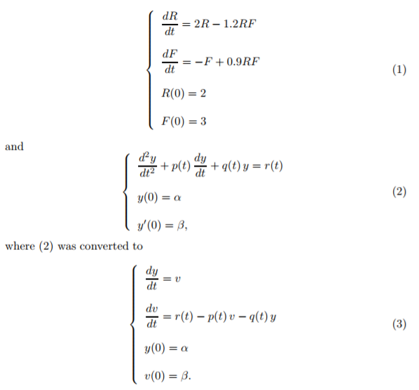

Both programs employ the Runge-Kutta 4th order method so I have defined a function that can be implemented in both programs.